Operating System (22516)
Unit -VI
File Mnagement: (Marks 10)
- 5.3 File – Concepts, Attributes Operations, Types, and File System Structure.
- 5.4 Access Methods – Sequential, Direct, Swapping, File Allocation Methods- Contiguous, Linked, Indexed.
- 5.5 Directory Structure – Single level, Two levels,tree structured directory, disk organization and disk structure. Physical structure,Logical structure,Raid structure of isk, raid level 0 to 6

File Concept
- A file is a collection of similar records. The file is treated as a single entity by users and applications and may be referred by name. Files have unique file names and may be created and deleted. Restrictions on access control usually apply at the file level.
- A file is a container for a collection of information. The file manager provides a protection mechanism to allow users administrator how processes executing on behalf of different users can access the information in a file. File protection is a fundamental property of files because it allows different people to store their information on a shared computer.
- File represents programs and data. Data files may be numeric, alphabetic, binary or alpha numeric. Files may be free form, such as text files. In general, file is sequence of bits, bytes, lines or records.
- A file has a certain defined structure according to its type.

1 Text File
2 Source File
3 Executable File
4 Object File

File Structure
Four terms are used for files
• Field
• Record
• Database
A field is the basic element of data. An individual field contains a single value. A record is a collection of related fields that can be treated as a unit by some application program.
A file is a collection of similar records. The file is treated as a single entity by users and applications and may be referenced by name. Files have file names and maybe created and deleted. Access control restrictions usually apply at the file level.
A database is a collection of related data. Database is designed for use by a number of different applications. A database may contain all of the information related to an organization or project, such as a business or a scientific study. The database itself consists of one or more types of files. Usually, there is a separate
database management system that is independent of the operating system.

File Attributes
File attributes vary from one operating system to another. The common attributes are,
Name – only information kept in human-readable form.
Identifier – unique tag (number) identifies file within file system
Type – needed for systems that support different types
Location – pointer to file location on device
Size – current file size
Protection – controls who can do reading, writing, executing .
Time, date, and user identification – data for protection, security, and usage monitoring
Information about files are kept in the directory structure, which is maintained on the disk
Creator or Owner – a creator is a user or person who has created that file and owner is the person who currently owns the file.

File Operations
File is an abstract data type. To define a file we need to consider the operation that can be
performed on the file. Basic operations of files are:
- Creating a file:-
- Two steps are necessary to create a file. First space in the file system for file is found.
- An entry for the new file must be made in the directory. The directory entry records the name of the file and the location in the file system.
- Writing a file:-
- System call is mainly used for writing in to the file.
- System call specify the name of the file and the information i.e., to be written on to the file.
- If the name of file is given then the system search the entire directory for the file.
- The system must keep a write pointer to the location in the file where the next write
to be taken place.
- Reading a file:-
- To read a file system call is used.
- It requires the name of the file and the memory address.
- Again the directory is searched for the file to be read.
- The system must maintain a read pointer to the location in the file where next read is to take place.
- Delete a file:-
- System will search for the directory for the file to be deleted.
- If entry is found it releases all free space.
- That free space can be reused by another file.
- Truncating the file:-
- User may want to erase the contents of the file but keep its attributes.
- Rather than forcing the user to delete a file and then recreate it, truncation allows all attributes to remain unchanged except the file length.
- Repositioning within a file:-
- The directory is searched for appropriate entry and the current file position is set to a given value.
- Repositioning within a file does not need to involve actual I/O.
- This file operation is also known as file seeks.

File Types – Name, Extension
A common technique for implementing file types is to include the type as part of the file name. The name is split into two parts : a name and an extension. Following table gives the file type with usual extension and function.
File Type | Usual Extension | Function
Executable | exe, com, bin | Read to run machine language program.
Object | obj, o | Compiled, machine language, not linked
Source Code | c, cc, java, pas asm, a | Source code in various language
Text | txt, doc | Textual data, documents

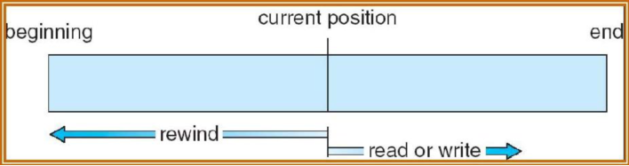

Advantages:
- Easy to access next record.
- It is useful for tape based systems.
- There is no specific data structure required.
- Using this method, automatic backup copy is created.
- Data organization is very simple.

Disadvantages:
- It is very slow.
- To access nth records system has to go through n-1 records.
- It can move only one record forward or backward at a time.
- It is time consuming process.

- Direct Access:
- Direct access allows random access to any file block.
- This method is based on disk model of a file.
- A file is made up of fixed length logical records.
- It allows the program to read and write records rapidly in any order.
- A direct access file allows arbitrary blocks to be read or written. Eg:-User may need block 13, then read block 99 then write block 12.
- For searching the records in large amount of information with immediate result, the direct access method is suitable.

Advantages:
- Accessing speed is very fast and Time required is less.
- Successive block can be accessed randomly without any head movement.

Note: All OS do not support sequential and direct access. Few OS use sequential access and some OS uses direct access. It is easy to simulate sequential access on a direct access but the reverse is extremely inefficient.

ALLOCATION METHODS
The space allocation strategy is closely related to the efficiency of the file accessing and of logical to
physical mapping of disk addresses. A good space allocation strategy must take in to consideration several factors such as:
1. Processing speed of sequential access to files, random access to files and allocation and de-
allocation of blocks.
2. Disk space utilization.
3. Ability to make multi-user and multi-track transfers.
4. Main memory requirement of a given algorithm.

Three major methods of allocating disk space are:

- Contiguous Allocation:
- In contiguous allocation, a set of contiguous blocks on the disk are allocated to a file at the time of file creation.
- The linear ordering of addresses is used for such storage method.
- If the file is n blocks long and starts at location b, then it occupies blocks b, b+1, b+2…………….b+n-1.
- The file allocation table entry for each file indicates the address of starting block and the length of the area allocated for this file.
- Contiguous allocation supports both Sequential and direct access methods.
- Contiguous allocation algorithm suffers from external fragmentation.
- Depending on the amount of disk storage the external fragmentation can be a major or minor problem.
- Compaction is used to solve the problem of external fragmentation.
- Another problem with this method is, if user wants to extend his file and the block on both sides of file is in use then the file can’t be extended. If larger hole is used to copy the content of a file then it creates internal fragmentation
- The following figure shows the contiguous allocation of space after compaction.
- The original disk was then freed completely creating one large contiguous space.

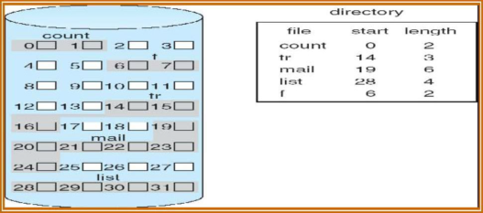

Advantages:
- Supports sequential and direct access.
- Best form of allocation for sequential files.
- It is easy to retrieve a single block from a file.
- It provides good performance.
Disadvantage:
- Pre-allocation is required.
- It suffers from external fragmentation.

- Linked Allocation:
- It solves all the problem of contiguous allocation. This allocation is on the basis of an individual block. Each block contains a pointer to the next block in the chain.
- The disk block can be scattered anywhere on the disk.
- The directory contains a pointer to the first and the last blocks of the file.
- To create a new file, simply create a new entry in the directory.
- The following figure shows the linked allocation.

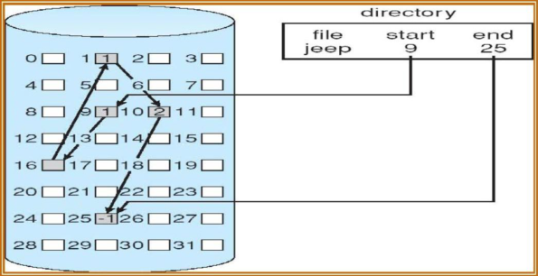

- There is no external fragmentation since only one block is needed at a time.
- The size of a file need not be declared when it is created.
- A file can continue to grow as long as free blocks are available
- This method is used only for a sequential access file
- This method requires more space to store pointers
- So instead of blocks, clusters are used for allocation but this creates internal fragmentation.
.
Advantages:
- No external fragmentation.
- Compaction is never required.
- Pre-allocation is not required.
- No need to know the size of a file in advance.

Disadvantage:
- It does not support direct access.
- Memory Space is wasted for storing pointers as 2 bytes are reserved in each block for storing pointers..
- To find n^{th} block of a file, searching shold start at the beginning of that file and follow the pointers until the i^{th} block is reached.
- Not reliable.

- Indexed Allocation:
- It brings all pointers together into one block called as index block
- Each file in the system has its own index block which contains pointers to disk blocks of that file i.e. the i th entry in the index block points to the i th block of the file
- The address of the index block is stored into the directory
- The following figure shows indexed allocation

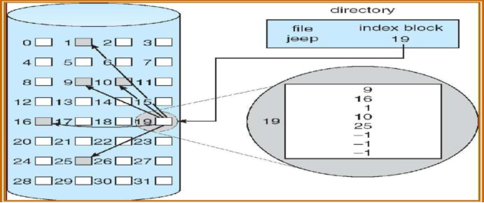

- The indexes are not stored as a part of file allocation table; rather the index is kept as a separate block and the entry in the file allocation table points to that block.
- Allocation can be made on either fixed size blocks or variable size blocks.
- When the file is created all pointers in the index block are set to nil. When an entry is made a block is obtained from free space manager. Allocation by fixed size blocks eliminates external fragmentation where as allocation by variable size blocks improves locality. Indexed allocation supports both direct access and sequential access to the file.

Advantages:
- Supports both sequential and direct access.
- No external fragmentation. Faster then other two methods.
- Supports fixed size and variable sized blocks.

Disadvantage:-
- Suffers from wasted space.
- Pointer overhead is generally greater

DIRECTORY STRUCTURE
The files systems can be very large. Some systems stores millions of files on the disk. To manage all this data we need to keep it organized. This organization is done in two parts:
1. Disks are split in to one or more partition also known as minidisks.
2. Each partition contains information about files within it.
This information is kept in entries in a device directory or volume table of contents.
The device directory or simple directory records information as name, location, size, type for all files on the partition.
The directory can be viewed as a symbol table that translates the file names in to the directory entries.
The directory itself can be organized in many ways.
When considering a particular directory structure, we need to keep in mind the operations that are to be performed on a directory.

Single-level directory:
This is the simplest directory structure. All the files are stored in the same directory which is easy to support and understand. But a unique name must be assigned to each file.
If the number of files in the directory increases, it may become difficult to remember names of all files.
Advantage:
- Less time required to search the file, because all files are stored in same directory.
Disadvantages
- Not suitable for a large number of files and more than one user.
- Because of single directory files, files require unique file names.
- Difficult to remember names of all the files as the number of files increases. MS-DOS OS allows only 11 character file name where as UNIX allows 255 character.

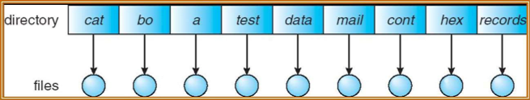

Two-level directory:
- A single level directory often leads to the confusion of file names between different users. The solution here is to create separate directory for each user.
- In two level directories each user has its own directory. It is called User File Directory (UFD). Each UFD has a similar structure, but lists only the files of a single user.
- When a user job starts or users logs in, the systems Master File Directory (MFD) is searched. The MFD is indexed by the user name or account number and each entry points to the UFD for that user.
- When a user refers to a particular file, only his own UFD is searched. Thus different users may have files with the same name.
- To create a file for a user, OS searches only those users UFD to ascertain whether another file of that name exists.
- To delete a file checks in the local UFD so that accidentally delete another user’s file with the same name.

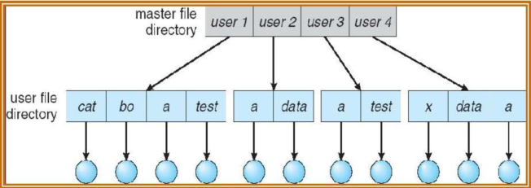

Advantage:
- It solves isolation. i.e data of one user is separated from other user.
- Searching is also efficient in this type of structure.
- Every user access his own directory and files.
- There is no problem of files with same names in different directories.
Disadvantage:
- Two users can not share data or communicate with each other.
- It is difficult to search the files with same names in different directories.

Tree-structured directories:
- It allows users to create their own directories and subdirectory and to organize their files accordingly.
- Directories can contain sub-directories and a subdirectory contains a set of files or again subdirectories.
- The data can be easily searched due to path concept. Path describes where exactly that file or directory is stored.
- There are two types of paths, one is absolute path and other is relative path.
- Absolute path name:- Begins at the root and follows a path down to the specified file, giving the directory names on the path.
- Relative path name:- Defines a path from the current directory.

- One important issue in this structure is how to handle the deletion of a directory if it already contains subdirectories or files.
a. If a directory is empty, its entry can simply be deleted.
b. If a directory is not empty, one of the two approaches can be used.
i. In MS-DOS, the directory is not deleted until it becomes empty.
ii. In UNIX, RM command is used with some options for deleting directory.

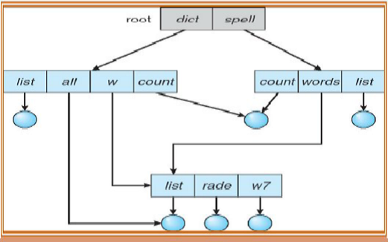

Advantages
- User can create directory as well as sub-directory.
- Users can access files of other users.
- Users can provide access to sub-directory rather than entire directory.
- It provides a better structure to file system.
- Managing millions of files become easy with this structure.
Disadvantage
- Search time may become unnecessary long.
- A path name has to be specified for searching of a file.
- One user can access files of other users.

File Protection
Millions of files containing important information are stored in computer system. Safety from physical damage and improper access must be provided to these files. The reliability and protection must be maintained for the information in computer system.
By providing duplicate copies of the file, reliability of the system can be maintained.
In some operating systems, system programs are provided to automatically copy disk files to tapes at regular interval.
Due to hardware problems like power surges or failures, head crashes, dirt, temperature extremes the file system can be damaged.
Sometimes file might be deleted accidently.
File contains may lose due to software bugs.

Types of file access

In some systems, it is necessary to provide controlled access to the files. The different types of operations that can be controlled are
- READ – Read from the file
- WRITE – Write or rewrite to the file
- EXECUTE – Load the file content into memory and execute it
- APPEND – Write new information at the end of the file
- DELETE – Delete the file and free its space for reuse
- LIST – List the names and attributes of the files
- RENAME
- COPY
- EDIT

Difference between sequential and direct access
Sr.no | Sequential Access | Direct Access
1. | It is based on tape based systems | It is based on disk based system.
2. | It is slow. | It is fast.
3. | To access nth record it has to scan (n-1) records. | It can directly access the required record or block.
4. | It has only two operations i.e. Go forward or move backward. | It does not have any operation.
5. | It can move only one record at at ime. | It can jump to any desired record.
6. | There is fixed reference position. | There is no fixed reference position.
7. | It is very tedious and time consuming. | It is not tedious and time consuming.
8. | For accessing large file the problem becomes much complex. | There is no difficulty in accessing large or small files.

Difference between contiguous and linked allocation
Sr.no | Contiguous allocation | Linked allocation
1. | It allocates successive or contiguous blocks to a file. | It does not allocates successive or contiguous blocks to a file.
2. | It supports sequential as well as direct access. | It supports only sequential access.
3. | The file size should be declared in advance. | No need to declare the file size.
4. | It suffers from external fragmentation. | It does not suffer from external fragmentation.
5. | Pointers are not required. | Pointers are required which needs an additional memory space.
6. | It can create problems when the file gets bigger. | File can grow to its required size.
7. | There is no problem of reliability. | There is a problem of reliability.
8. | Head movement is not required to access the successive blocks. | Head movement may be required to access the random blocks.

Sr.no | Paging | Segmentation
1. | It divides primary memory into fixed size blocks called page frames and the program’s address space into same size units called pages. | It is the only memory management technique that does not provide user program with a linear and contiguous address space.
2. | Page is indicated by its number and offset. | Segment is indicated by segment number and its offset.
3. | The memory management unit maps pages to page frames. | Any segment can’t be loaded into any free physical memory segment.
4. | Page table is formed. | Segment table is formed.
5. | Paging is invisible to the user. | Segmentation is visible to the user.
6. | Paging is faster than segmentation. | Segmentation is slower than paging.
7. | Paging suffers from internal fragmentation. | Segmentation suffers from external fragmentation.
8. | In paging, all pages are of equal size i.e power of 2. | In segmentation, all segments are of variable size.

What is RAID?
RAID stands for Redundant Array of Inexpensive Disks which was later interpreted to Redundant Array of Independent Disks. This technology is now used in almost all the IT organizations looking for data redundancy and better performance. It combines multiple available disks into 1 or more logical drive and gives you the ability to survive one or more drive failures depending upon the RAID level used.

Why to use RAID?
With the increasing demand in the storage and data world wide the prime concern for the organization is moving towards the security of their data. Now when I use the term security, here it does not means security from vulnerable attacks rather than from hard disk failures and any such relevant accidents which can lead to destruction of data. Now at those scenarios RAID plays it magic by giving you redundancy and an opportunity to get back all your data within a glimpse of time.

Levels
Now with the moving generation and introduction of new technologies new RAID levels started coming into the picture with various improvisation giving an opportunity to organizations to select the required model of RAID as per their work requirement.
Now here I will be giving you brief introduction about some of the main RAID levels which are used in various organizations.

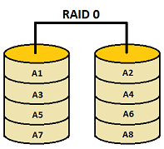RAID 0

This level strips the data into multiple available drives equally giving a very high read and write performance but offering no fault tolerance or redundancy. This level does not provides any of the RAID factor and cannot be considered in an organization looking for redundancy instead it is preferred where high performance is required.
Calculation:
No. of Disk: 5
Size of each disk: 100GB
Usable Disk size: 500GB
Pros | Cons
Data is stripped into multiple drives | No support for Data Redundancy
Disk space is fully utilized | No support for Fault Tolerance
Minimum 2 drives required | No error detection mechanism
High performance | Failure of either disk results in complete data loss in respective array

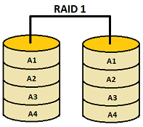RAID 1
This level performs mirroring of data in drive 1 to drive 2. It offers 100% redundancy as array will continue to work even if either disk fails. So organization looking for better redundancy can opt for this solution but again cost can become a factor.
Calculation:
No. of Disk: 2
Size of each disk: 100GB
Usable Disk size: 100GB
Pros | Cons
Performs mirroring of data i.e identical data from one drive is written to another drive for redundancy. | Expense is higher (1 extra drive required per drive for mirroring)
High read speed as either disk can be used if one disk is busy | Slow write performance as all drives has to be updated
Array will function even if any one of the drive fails
Minimum 2 drives required

RAID 2
This level uses bit-level data stripping rather than block level. To be able to use RAID 2 make sure the disk selected has no self disk error checking mechanism as this level uses external Hamming code for error detection. This is one of the reason RAID is not in the existence in real IT world as most of the disks used these days come with self error detection. It uses an extra disk for storing all the parity information
Calculation:
Formula: n-1 where n is the no. of disk
No. of Disk: 3
Size of each disk: 100GB
Usable Disk size: 200GB
Pros | Cons
BIT level stripping with parity | It is used with drives with no built in error detection mechanism
One designated drive is used to store parity | These days all SCSI drives have error detection
Uses Hamming code for error detection | Additional drives required for error detection

RAID 3
This level uses byte level stripping along with parity. One dedicated drive is used to store the parity information and in case of any drive failure the parity is restored using this extra drive. But in case the parity drive crashes then the redundancy gets affected again so not much considered in organizations.
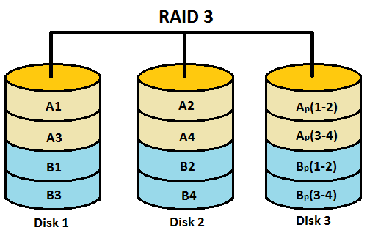
Calculation:
Formula: n-1 where n is the no. of disk
No. of Disk: 3
Size of each disk: 100GB
Usable Disk size: 200GB
Pros | Cons
BYTE level stripping with parity | Additional drives required for parity
One designated drive is used to store parity | No redundancy in case parity drive crashes
Data is regenerated using parity drive | Slow performance for operating on small sized files
Data is accessed parallel
High data transfer rates (for large sized files)
Minimum 3 drives required

RAID 4
This level is very much similar to RAID 3 apart from the feature where RAID 4 uses block level stripping rather than byte level.
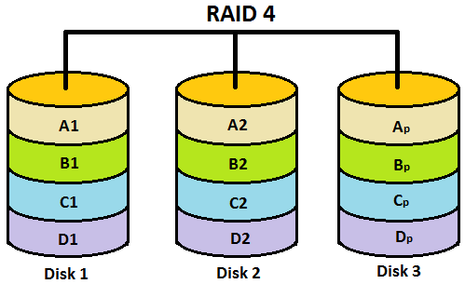
Calculation:
Formula: n-1 where n is the no. of disk
No. of Disk: 3
Size of each disk: 100GB
Usable Disk size: 200GB
Pros | Cons
BLOCK level stripping along with dedicated parity | Since only 1 block is accessed at a time so performance degrades
One designated drive is used to store parity | Additional drives required for parity
Data is accessed independently | Write operation becomes slow as every time a parity has to be entered
Minimum 3 drives required
High read performance since data is accessed independently.

RAID 5
It uses block level stripping and with this level distributed parity concept came into the picture leaving behind the traditional dedicated parity as used in RAID 3 and RAID 5. Parity information is written to a different disk in the array for each stripe. In case of single disk failure data can be recovered with the help of distributed parity without affecting the operation and other read write operations.
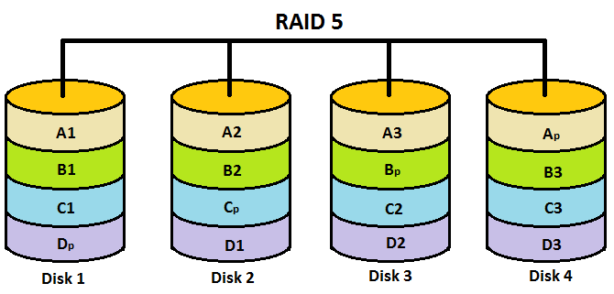
Calculation:
Formula: n-1 where n is the no. of disk
No. of Disk: 4
Size of each disk: 100GB
Usable Disk size: 300GB
Pros | Cons
Block level stripping with DISTRIBUTED parity | In case of disk failure recovery may take longer time as parity has to be calculated from all available drives
Parity is distributed across the disks in an array | Cannot survive concurrent drive failures
High Performance
Cost effective
Minimum 3 drives required

RAID 6
This level is an enhanced version of RAID 5 adding extra benefit of dual parity. This level uses block level stripping with DUAL distributed parity. So now you can get extra redundancy. Imagine you are using RAID 5 and 1 of your disk fails so you need to hurry to replace the failed disk because if simultaneously another disk fails then you won't be able to recover any of the data so for those situations RAID 6 plays its part where you can survive 2 concurrent disk failures before you run out of options.
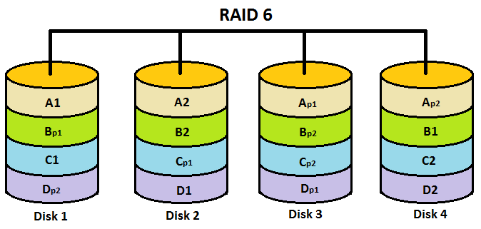
Calculation:
Formula: n-2 where n is the no. of disk
No. of Disk: 4
Size of each disk: 100GB
Usable Disk size: 200GB
Pros | Cons
Block level stripping with DUAL distributed parity | Cost Expense can become a factor
2 parity blocks are created | Writing data takes longer time due to dual parity
Can survive concurrent 2 drive failures in an array
Extra Fault Tolerance and Redundancy
Minimum 4 drives required

